Who is it run by?
The course will be run by Andy Harris (Leader of Youth Mission and Ministry, Durham Diocese) John Stephenson (Youth Work Adviser URC Northern Synod) and Lena Stephenson (reNEw NE founder) and other local youth leaders. All leaders will be appropriately vetted (including DBS checking). All activities are subject to sensible risk assessment to minimise the chances of injury or accidents. In all activities there is a ratio of at least 1 adult to every 8 young people.
Programme
Date/s | Time | Location | Theme
Fri 20th Sept/ Sat 21st Sept  2019 | 6.30pm -4.30pm | Cuthbert House | Residential  - Leadership Matters  - Remember who and whose you are
Sat 9th Nov | 10.30-1pm | Cuthbert House | - Getting to the heart
Sat 7th Dec | 10.30-1pm | Cuthbert House | - Leading where you are
Sat 11th Jan 2020 | 10.30-1pm | Cuthbert House | - Part of the team
Fri 7th Feb /  Sat 8th Feb | 6.30pm -4.30pm | Cuthbert House | Residential  - Growing your gifts
Sat 7th March | 10.30-1pm | Cuthbert House | Projects  - The bigger picture
Sat 4th April | 10.30-2pm | Cuthbert House | - Keeping on growing – Final Presentation
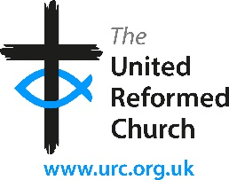
NB There may be some dates that you might not be able to make, but we would expect young people to be there for the majority of the course.
Further details
Andy Harris andy.harris@durham.anglican.org Tel: 07796769307
John Stephenson john.stephenson@urc-northernsynod.org Tel: 07849 670210
Lena Stephenson lena.stephenson@renewne.org.uk Tel: 07479 283706
Kate Martin kate.martin@durham.anglican.org Tel: 0191 3746017
Booking
Booking is now open. Spaces are limited so early booking is recommended.
Youth Leadership Training
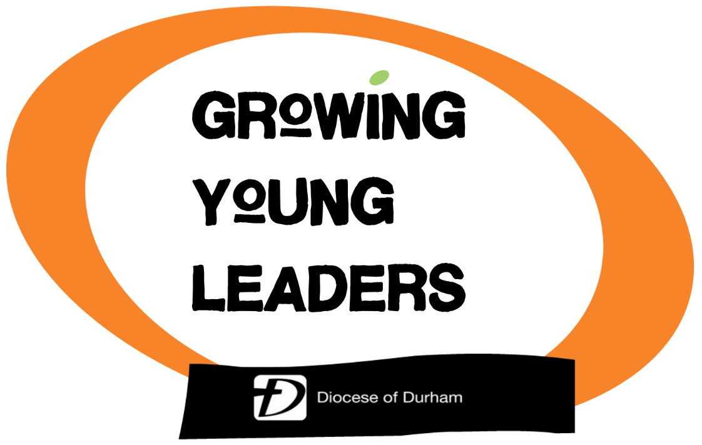
September 2019 – April 2020

Are you in year 10-13 and looking for the opportunity to grow in your leadership skills?

Booking Form
The form below (or copy) should be completed and returned to Kate Martin, Cuthbert House, Stonebridge, Durham DH1 3RY together with the £10 deposit (non-returnable) cash or cheque (made payable to ‘DDBF’).
Booking can also be made online (or via https://durhamdiocese.org/youth )
Young Persons Details
Forename: _________________________________________
Surname: _________________________________________
Date of Birth: ___________ Gender _____
Church (or School) ___________________________________
Parent/Carer Details
Forename: ________________________________________
Surname: ________________________________________
Phone number: _____________________
Email address: _____________________________________
Address: __________________________________________
__________________________________________________
__________________________________________________
I give permission for my child to attend the course.
Parent/Carer
Signature: _____________________________
Date: _________________________________
(NB There will be a further consent form including health and dietary requirements to complete)
The Course
Leadership is not just about holding a top position, like being a team captain or having responsibility at school or even church. Leadership is about making a difference wherever we are: at school, at college, in the community or at home.
Growing Young Leaders is all about having fun together while exploring how we can grow in the God-given gift of leadership. The course will be about considering how we can each be an effective leader, what gifts and abilities we have, how we can grow as a leader and explore what God calls us to do.
We will learn together through talks, discussions as well as games, challenges and activities. The course will also include a project to develop and demonstrate leadership skills.
Growing Young Leaders is based on a CPAS course.

Who is it for?
It is for young people in years 10-13 (in September 2019). You can come as part of a church youth group or just by yourself and make new friends!

How much does it cost?
The course costs £60 in total, to include both residentials, food and materials.
- £10 deposit now to secure a place (non-returnable)
- £25 by Nov 9th (or full balance of £50 if preferred)
- £25 by 11th January 2020
Payments can be made by cash or cheque (made payable to ‘DDBF’). Participants from URC churches can apply for support from the Synod – details after booking.

Some feedback from this year
‘Honestly I loved it all so much, I wish there had been more residentials but it was loads of fun’; ‘I’ve enjoyed the sense belonging and community’; ‘I really enjoyed meeting new people who share the same faith’; ‘I have particularly enjoyed the residentials as it gave us a chance to get to know each other and develop our skills as a leader’; ‘I’ve learnt to have more confidence in my abilities and to see ones I didn’t realise I had’; ‘I’m much more confident within myself and my faith’; ‘I’ve learnt how to be a good leader in a Christian context’; ‘I have learnt I have a voice’; ‘I’ve learnt you can be a leader at any age’; ‘I’d do it again if I could’.

‘Everything about the course has been hugely impressive and faith-building’. (Parent)

