The Holy Spirit Retreat Day
This retreat day is offering a chance to reflect more about the Holy Spirit and be refreshed and renewed through the day by the Holy Spirit.
The idea is that you can pick and mix from this material. You will be provided with the structure, but you can change and rearrange it as it suits your daily routine and family situation.
It would be good to have a song or a verse to start and finish every section of this retreat.
For example: Chris Tomlin “Spirit fall”, Keith & Kristyn Getty “Holy Spirit, Living breath of God”, Hillsong Worship, “Welcome in this place” or use the following invocation of the Holy Spirit.
- 8:30 – 9:30 am
Invocation of the Holy Spirit:
Most powerful Holy Spirit,
Come down
Upon us
And subdue us.
From heaven,
Where the ordinary
Is made glorious,
And glory seems
But ordinary,
Bathe us
With the brilliance
Of Your light
Like dew.

Read the following verses and make a note after reading each verse – what does the Holy Spirit do, what are His actions:
John 14:26, 1 Corinthians 12:13, Acts 1:8, Psalm 139:7-10
Spend some time writing your reflections about the Holy Spirit’s actions – do you notice His work in you in the way it is described in these verses? In what way?
End your time with the invocation or a song

- 9:30 – 11 am
Start your time with the invocation or a song
Read the following verses and make a note after reading each verse – what does the Holy Spirit do, what are His actions:
Romans 8:15, 1Corinthians 3:16, Romans 8:26, 1 Corinthians 6:19, Isaiah 11:2, John 14:15-17, Luke 11:13,
Did you learn anything new about the Holy Spirit and His actions?
Draw a picture of the words/verses that stand out to you.
Spend some time writing your reflections about the Holy Spirit’s actions – do you notice His work in you in the way it is described in these verses? In what way?
End your time with the invocation or a song.
- 11:00-12:00 am
Start your time with the invocation or a song
Look at the following pictures. Think - in what way do they remind you about the Holy Spirit? Write a prayer about your association next to each picture.
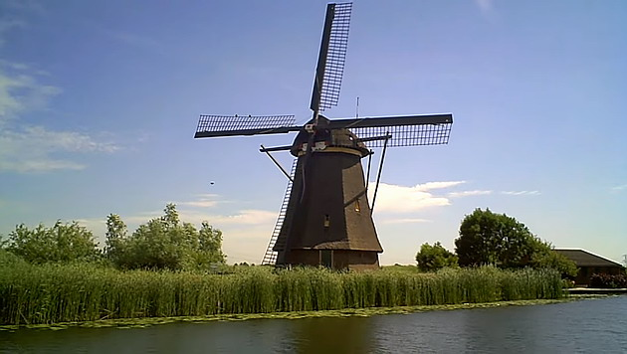
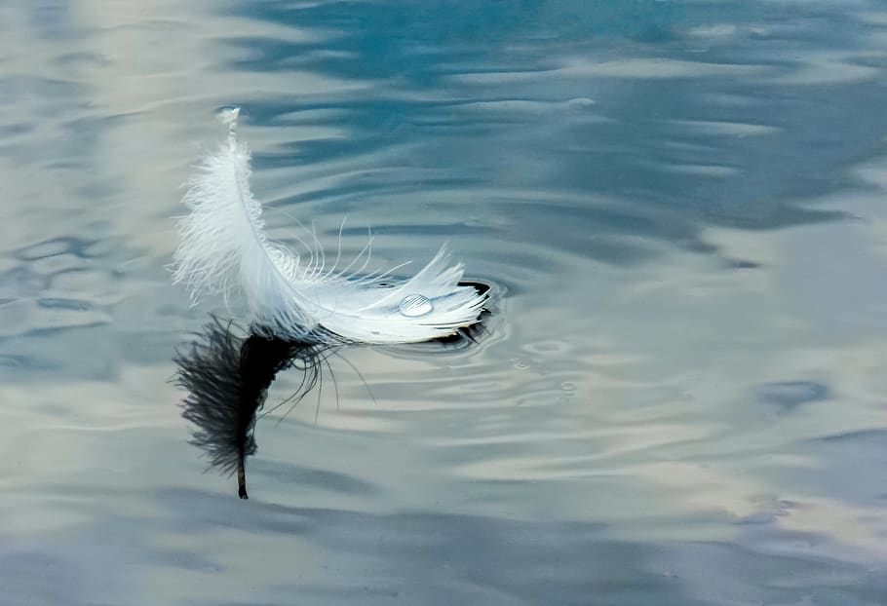
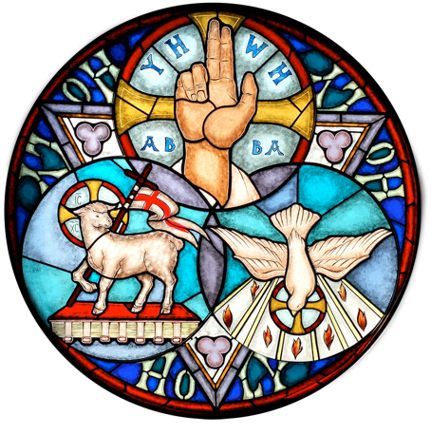

Which picture stands out most to you? Spend more time thinking and reflecting about that picture.
End your time with the invocation or a song
- 12-1:30 pm LUNCH

- 1:30 – 2:30 pm
Start your time with the invocation or a song
Read the following verses and make a note after reading each verse – what does the Holy Spirit do, what are His actions:
Ezekiel 36:26, John 16:13, Acts 2:17, 2Corinthians 3:18
Which verses stand out to you?
Spend some time writing your reflections about the Holy Spirit’s actions – do you notice His work in you in the way it is described in these verses? In what way?
End your time with the invocation or a song

- 2:30 - 3:30 pm
Start your time with the invocation or a song
Learn Galatians 5: 22-23 off by heart.
Think of the fruit of the Spirit:
- Which one do you desire to show more of in my everyday life?
- Which fruit do you find hard to show?
Take some time to talk to the Holy Spirit about these questions.
You can pray about them using these scriptures:

Love – 1Corinthians 13:4-8
Joy – Psalm 16:8-11
Peace – Isaiah 26:3
Patience – Psalm 37:5-7
Kindness – Ephesians 4:32
Goodness – Ephesians 2:10
Faithfulness – Matthew 25:21
Gentleness – 1Petre 3:4
Self-control – 2Timothy 1:7
End your time with the invocation or a song

- 4:30 - 5:30 pm
Start your time with the invocation or a song
Read the following verses and make yourself a note after reading each verse – what does the Holy Spirit do, what are His actions:
Ephesians 1:13, Romans 15:30, Romans 14:17, Romans 8:11
Spend some time writing your reflections about Holy Spirit actions – do you notice His work in you in the way it is described in these verses? In what way?
End your time with the invocation or a song

- 5:30 – 6:30 pm
Start your time with the invocation or a song
Do the colouring sheet that’s at the end of this retreat pack, or walk, or enjoy thequietness of your garden.
Meanwhile reflect and meditate on these questions:
- Is there a theme that has come out from today that the Holy Spirit wishes to talk with you about?
- What have you discovered about the Holy Spirit today or were reminded of?
- Which verses/pictures stood out to you?

End your day with this prayer: A Prayer of thanks to the Holy Spirit
Holy Spirit,
You are God. I praise you because you are holy, and I thank you for dwelling in my heart. Thank you for working in my life. You guided me into salvation, renewed my dead spirit, and you opened my eyes to the Truth. Thank you.
Help me to see you more clearly – to recognize your movement in my life. Make me more sensitive to you so I can follow you more closely. Still, I know that I am selfish and rebellious. I need you to help me be obedient when I recognize your leading. I need you.
I ask you for your help and comfort today. You know my pain and anxieties very well. Thank you for praying over me. Help me to rest in your comfort today.
Help me to walk in you, the Spirit of God. Grow good fruit in my life. You are the one who produces these in me: love, joy, peace, patience, kindness, goodness, faithfulness, gentleness, and self-control. Thank you for growing __________ in me. Please grow more of _________ in me. I cannot live out these things on my own; I need you.
Amen
